**MGNDTI: A drug-target interaction prediction framework based on multimodal representation learning and the gating mechanism**

**(Supplementary Materials)**

Lihong Peng1, Xin Liu1, Min Chen2*, Wen Liao3, Jiale Mao3, Liqian Zhou1*

1 College of Life Science and Chemistry, Hunan University of Technology, Zhuzhou, 412007, Hunan, China.

2 School of Computer Science and Engineering, Hunan Institute of Technology, Hengyang, 421002, China.

3 School of Computer Science, Hunan University of Technology, Zhuzhou, 412007, Hunan, China.

* Corresponding authors: Min Chen (<chenmin@hnit.edu.cn>); Liqian Zhou ([zhoulq11@163.com](mailto:zhoulq11@163.com)).

1. Comparison results on BioSNAP and BindingDB

Our proposed MGNDTI model was compared with seven baseline methods using accuracy, F1-score and MCC under four different experimental settings E1, E2, E3 and E4 on BioSNAP and BindingDB. The results are shown in Figure S1:

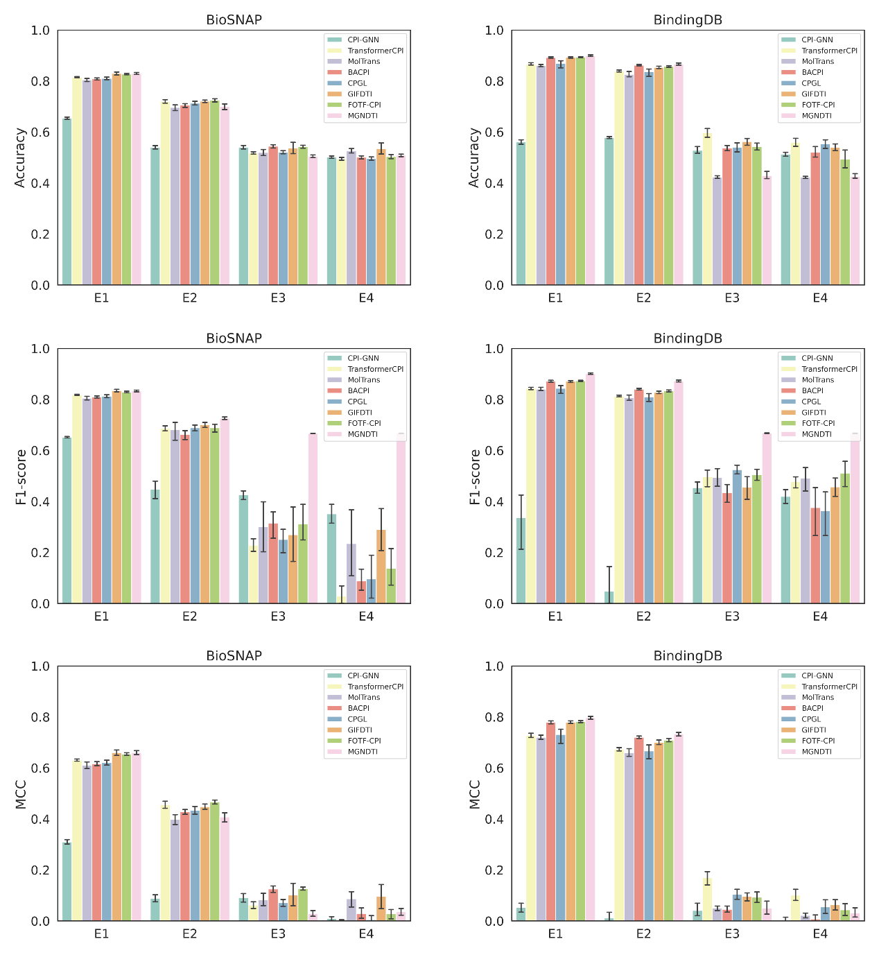

Figure S1 Accuracy, F1-score, and MCC computed by MGNDTI and seven baseline methods (10 random runs).

1. Ablation experiments on BioSNAP and BindingDB

The ablation experiment results on BioSNAP and BindingDB: (1) MGNDTI variants based on drug uni-modality and multi-modality: SGNDTI (drug SMILES sequence + protein sequence) and GGNDTI (drug molecular graph + protein sequence) in Figure S2, and (2) three other variants of MGNDTI: CatDTI (MGNDTI without multi-modal gating network), MSEDTI (MGNDTI without GLU), and GLUDTI (MGNDTI without MSE loss) in Figure S3.

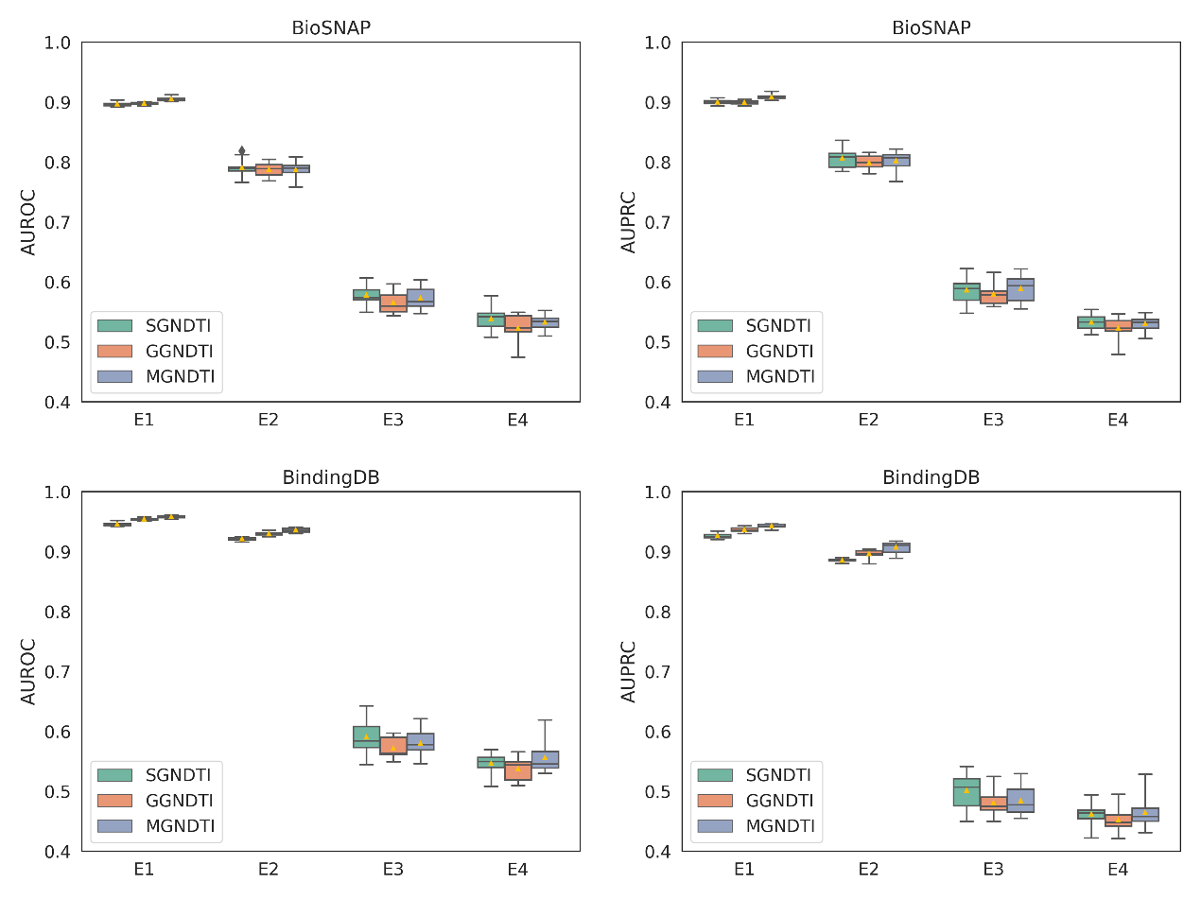

Figure S2 Ablation experiments on drug multi-modality on BioSNAP and BindingDB under four experimental settings (10 random runs).

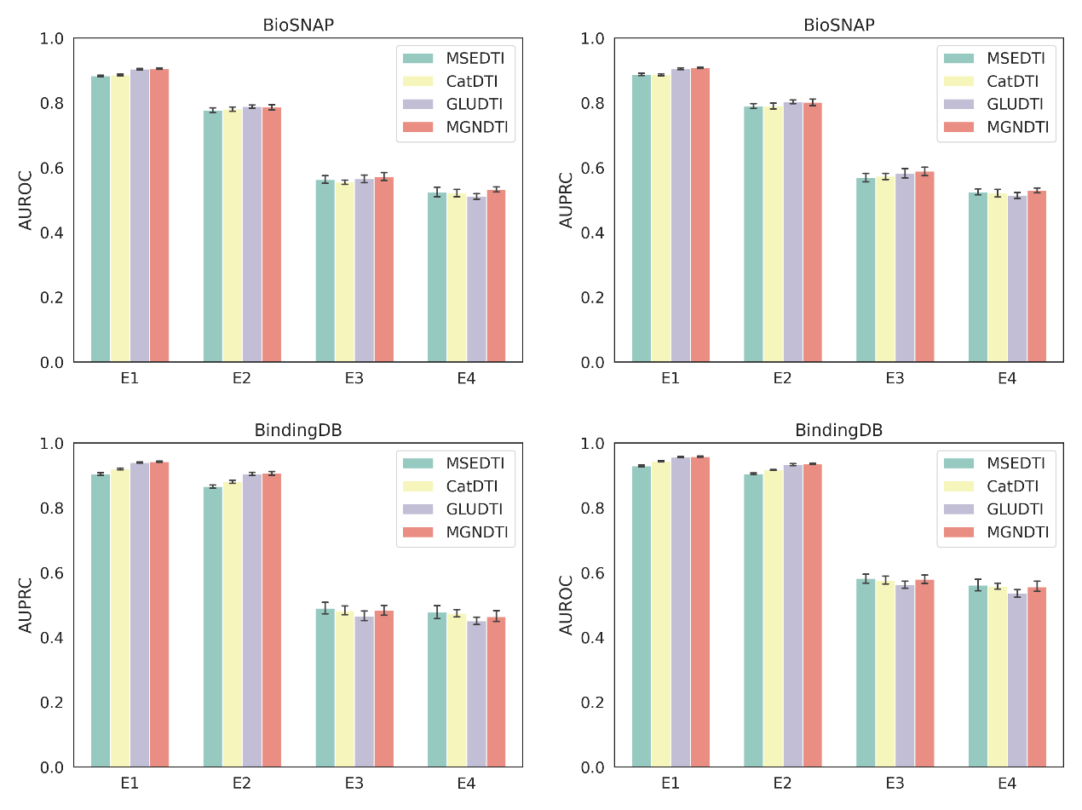

Figure S3 Ablation experiments on multi-modal gating networks on BioSNAP and BindingDB under four experimental settings (10 random runs).

1. Visualization on BioSNAP and BindingDB

The distributions of feature visualization on BioSNAP and BindingDB. We use dUMAP (Uniform Manifold Approximation and Projection) to reduce the dimensionality of the three types of features extracted by MGNDTI (with or without MSE loss) and visualized their feature distributions, and the visualization results are shown in Figure S4.

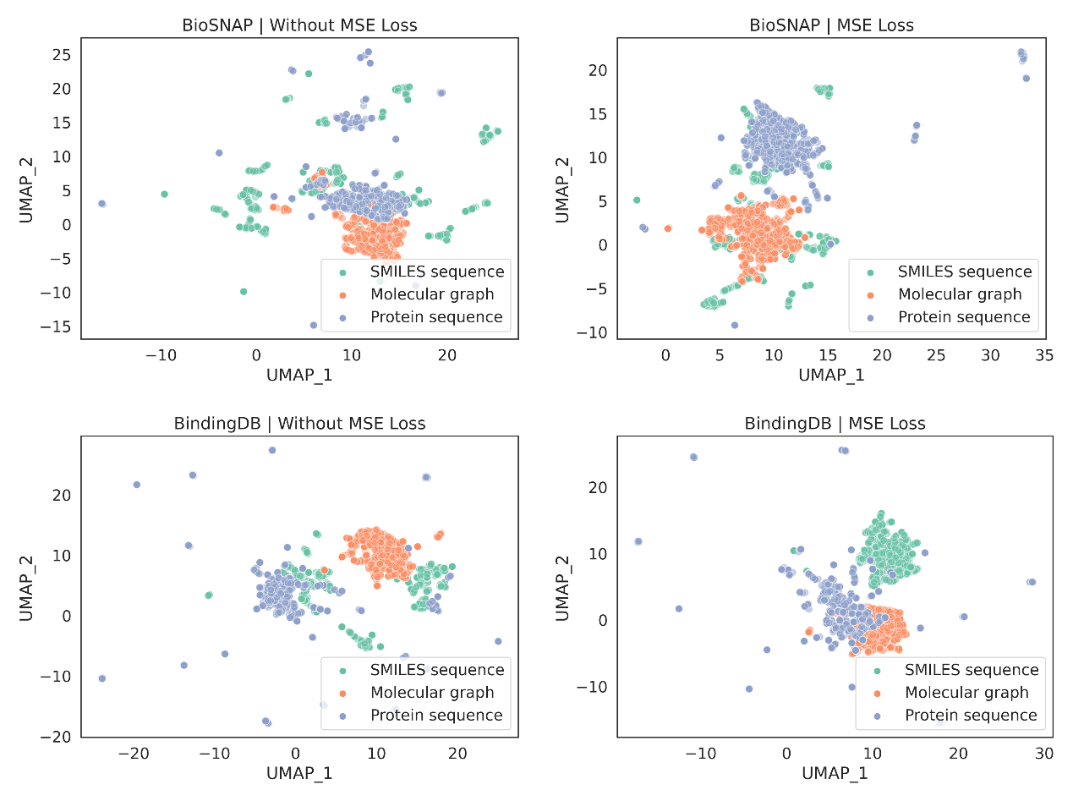

Figure S4 Distribution of multi-modal feature visualizations. UMAP visualization of multi-modal features on BioSNAP and BindingDB in MGNDTI with MSE loss or not.